Test Plan
Eventual desired output:
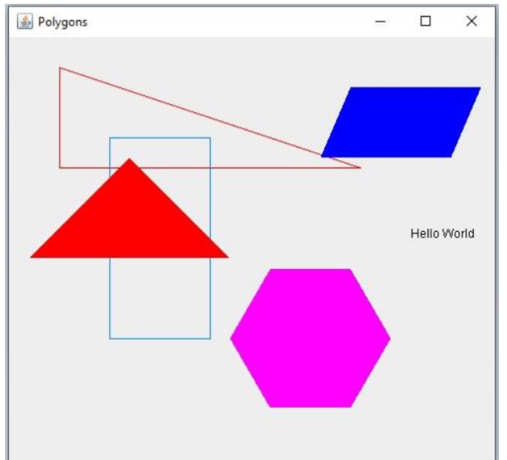
Test 1: Isosceles triangle
Input:
Scene Polygons (500, 500)
RightTriangle Color (255, 0, 0) at (50, 30) Height 100 Width 300;
Rectangle Color (0, 128, 255) at (100, 100) Height 200 Width 100;
Isosceles Color (255, 0, 0) at (120, 120) Height 100 Width 200;
End.

Desired output: Right triangle, isosceles triangle, and rectangle from graphic.
Actual output:
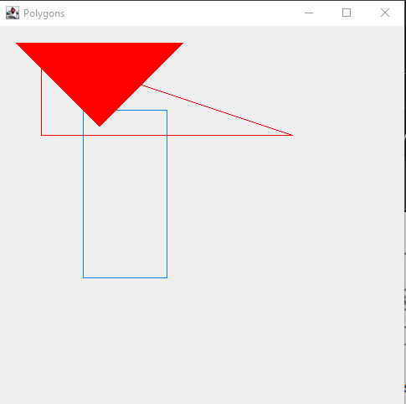
I mean, I didn’t not get the desired output, as I defined it…still, let’s get it to flip over.
I forgot the graphics pane has the origin at the top left and swapped my – and + accordingly.
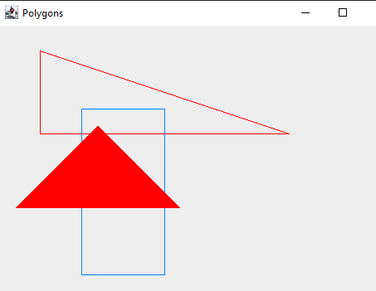
Pass.

Test 2: Parallelogram
Input:
Scene Polygons (500, 500)
RightTriangle Color (255, 0, 0) at (50, 30) Height 100 Width 300;
Rectangle Color (0, 128, 255) at (100, 100) Height 200 Width 100;
Parallelogram Color (0, 0, 255) at (340, 50) (440, 120) Offset 30;
End.

Desired output: Right triangle, rectangle, and parallelogram from graphic.
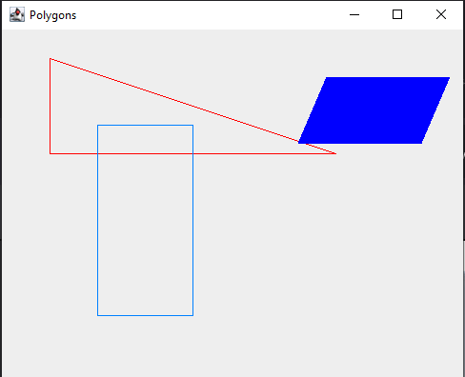
Pass.

Test 3: Regular Polygons
Input:
Scene Polygons (500, 500)
RightTriangle Color (255, 0, 0) at (50, 30) Height 100 Width 300;
Rectangle Color (0, 128, 255) at (100, 100) Height 200 Width 100;
RegularPolygon Color (255, 0, 0) at (120, 120) Sides 3 Radius 100;
RegularPolygon Color(255, 0, 255) at (300, 300) Sides 6 Radius 80;
RegularPolygon Color(0, 0, 0) at (400, 200) Sides 4 Radius 70;
End.

Expected output: The rectangle, right triangle, and hexagon from the graphic, as well as an equilateral triangle and a square where the isosceles triangle and text ought to go.
Actual output:
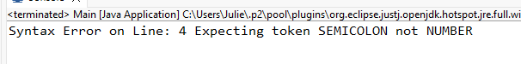
Line 4 of what, exactly?
…It would probably help if I uncommented the regular polygon text in the parser. And put all the right token checks in the parser. So I did that.

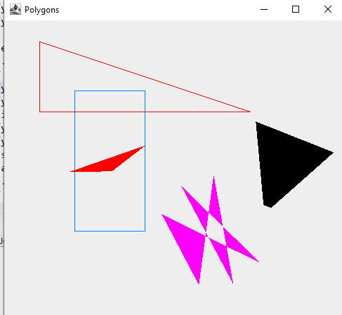
I have some polygons now, but they’re not the right ones.
Turns out the trig functions take radians, not degrees. I rewrote my math to work with radians.
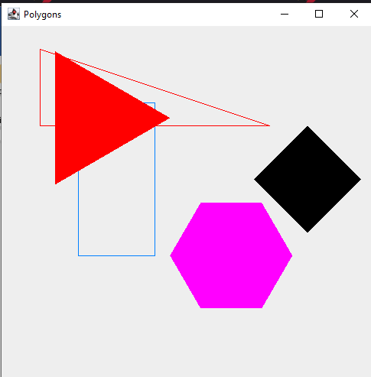
Pass.

Test 4: Text
Input:
Scene Polygons (500, 500)
RightTriangle Color (255, 0, 0) at (50, 30) Height 100 Width 300;
Rectangle Color (0, 128, 255) at (100, 100) Height 200 Width 100;
Isosceles Color (255, 0, 0) at (120, 120) Height 100 Width 200;
Parallelogram Color (0, 0, 255) at (340, 50) (440, 120) Offset 30;
RegularPolygon Color(255, 0, 255) at (300, 300) Sides 6 Radius 80;
Text Color(0, 0, 0) at (400, 200) "Hello World";
End.

Expected output: The end state graphic.
Actual output:
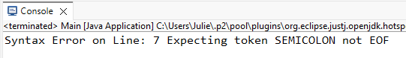
Okay, so I’m parsing it wrong. I checked over the list of parse calls and found a missing one.
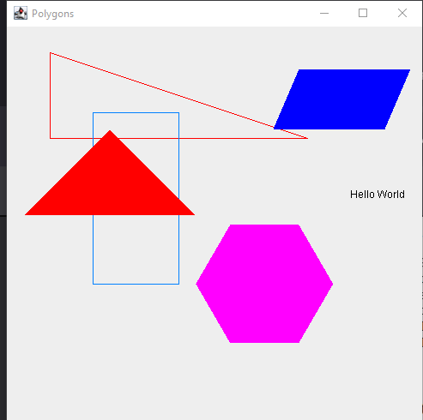
Pass!

